**Saint Brigid Saint John the Baptist**

13th Sunday in

Ordinary Time

July 1, 2018

**Catholic Church Catholic Church**

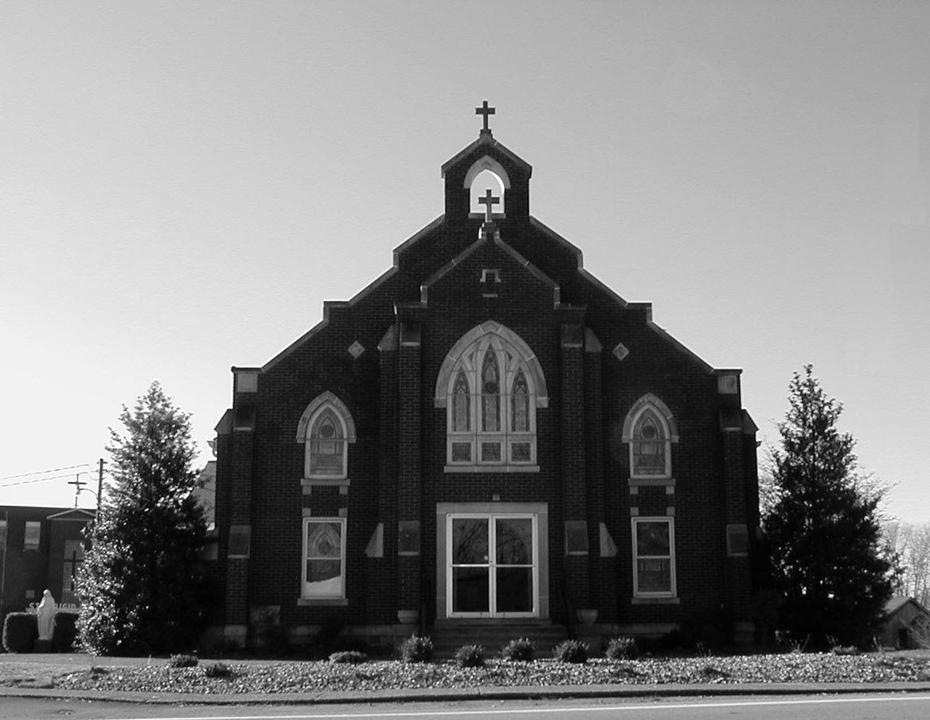

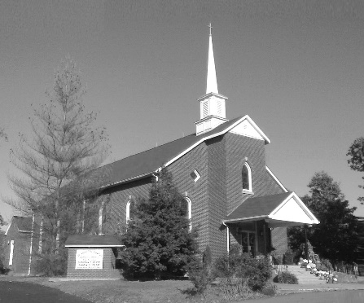

**Pastor:**

***Rev. Daniel L. Lincoln***

Rectory: (270) 877-2546

**Deacon:**

***Michael A. Ryan***

(270) 272-6789

314 E. Main St. 657 St. John Church Rd.

Vine Grove, KY 40175 Elizabethtown, KY 42701

Clustered Parish Office: Clustered Parish Office:

(270) 877-2461 (270) 877-2461

**ANNOINTING OF THE SICK:**

Notify the parish office when a family member is hospitalized.

**BAPTISM:**

Contact the parish office for information about the required preparation class.

**BULLETIN:**

Information must be submitted in writing by note or email to the parish office **no later than 12:00 noon on Wednesdays** for the following weekend. When sending an email, please put “BULLETIN,” and the name of the parish the announcement is for, in the subject line.

**MARRIAGE:**

Contact Father at least 6 months prior to the wedding date to complete required marriage preparations and to schedule the date.

**RCIA (Rite of Christian Initiation of Adults):**

Contact the Worship Chairperson for information.

**DEW MEMORIAL LIBRARY:**

(in St. Brigid Church basement):

Open: Sunday after 9:30 a.m. Mass& 45 minutes before all other Masses.

Email: [brigidvg@bbtel.com](mailto:brigidvg@bbtel.com)

Website: [www.stbrigidvg.org](http://www.stbrigidvg.org)

**Pastoral Associate & Dir. Dir. of Religious Education:**

**of Religious Education:** Lisa Thomas: (270) 735-6930

Deacon Mike Ryan: (270) 877-0546

**Youth Minister: Youth Ministers:**

Lori Law: (270) 723-0157 Angela Churchman:

(270) 268-9963

Ericka Finlay: (502) 612-2644

**MASS SCHEDULE:**

*Sunday:* 9:30 a.m. & 6:30 p.m.

*Monday:* 9:00 a.m.

*Thursday:* 9:00 a.m.

**RECONCILIATION:**

Sunday before Mass

5:30-6:00 p.m. or by appt.

**ROSARY:**

After weekday Masses

**PARISH COUNCIL MEMBERS:**

*President:* Sue Weisshaupt

*Vice-President:* Mike Bramlett

*Secretary:* Judy Cochran

*At-Large Members:* Blake Ryan

& Vincent Thompson

**CHAIRPERSONS:**

*Administration:* Dale Winchester

*Formation:* Tina Yates

*Parish Life:* Tom Billings

*Worship:* Keith Baughman

**MASS SCHEDULE:**

*Saturday (Vigil):*  6:30 p.m.

*Sunday:* 11:30 a.m.

*Wednesday:* 6:30 p.m.

*Friday:* 9:00 a.m.

**RECONCILIATION:**

Saturday before Mass

5:30-6:00p.m. or by appt.

**PARISH COUNCIL MEMBERS:**

*President:* Lauran Thomas

*Secretary:* Theresa Smith

**CHAIRPERSONS:**

*Administration:*  Nick Thomas

*Formation:* Ericka Newton

*Parish Life:* Bradley Wickersham

*Worship:* Greg Thompson



**Mass Schedule**

**Mass Schedule**

|  |  |  |  |  |  |
| --- | --- | --- | --- | --- | --- |
| **Saturday** | **June 30** | **6:30 p.m.** | **St. John** | **Anna Brangers** | **Vigil: 13th Sunday in Ordinary Time** |
| **Sunday** | **July 1** | **9:30 a.m.** | **St. Brigid** | **Our Parish Family**  **Mike Mullarkey** | **13th Sunday in Ordinary Time** |
| **“** | **“** | **11:30 a.m.** | **St. John** | **For All Parishioners**  **Eric Yates** | **“** |
| **“** | **“** | **6:30 p.m.** | **St. Brigid** | **Billy Cecil** | **“** |
| **Monday** | **July 2** | **9:00 a.m.** | **St. Brigid** | **Inge Luther, Cameron Ponder**  **& Luise Weisshaupt**  **Dickie Cecil** | **Weekday** |
| **Wednesday** | **July 4** | **6:30 p.m.** | **St. John** | **Bruce Sherrard** | **Weekday** |
| **Thursday** | **July 5** | **9:00 a.m.** | **St. Brigid** | **Clarence Jenkins**  **Helen C. “Dinky” Adams** | **Weekday** |
| **Friday** | **July 6** | **9:00 a.m.** | **St. John** | **In Thanksgiving** | **Weekday** |
| **Saturday** | **July 7** | **6:30 p.m.** | **St. John** | **Living & Deceased Emil & Anna Brangers Family Members** | **Vigil: 14th Sunday in Ordinary Time** |
| **Sunday** | **July 8** | **9:30 a.m.** | **St. Brigid** | **Our Parish Family**  **Carlos Robbins** | **14th Sunday in Ordinary Time** |
| **“** | **“** | **11:30 a.m.** | **St. John** | **For All Parishioners** | **“** |
| **“** | **“** | **6:30 p.m.** | **St. Brigid** | **Richard Hughes**  **Helen C. “Dinky” Adams** | **“** |

**INFORMATION FOR BOTH PARISHES**

**ABORTION AND ADOPTION –** The number of would-be adoptive parents (of newborn babies) far outstrips the supply in America. Each year in the United States, about 135,000 American children are placed for adoption. Experts estimate somewhere between one and two million couples seek to adopt yearly. Every year, there are about 1.3 million abortions. Sadly, only 4% of women with unwanted pregnancies give their children up for adoption. Every child is wanted and wanted desperately! By Pro-Life Articles Author [www.pro-lifearticles.org](http://www.pro-lifearticles.org)

**PROJECT RACHEL** **–** Healing…Forgiveness…Hope…After the experience of an abortion. If you or someone you know is struggling with the pain from an abortion, please consider Project Rachel – a post abortion ministry. To speak to someone confidentially, call (502) 471-2155 or email [ProjectRachel@archlou.org](mailto:ProjectRachel@archlou.org).

**CONFIDENTIAL PREGNANCY AND ADOPTION COUNSELING** – is available at Catholic Charities for women of all ages experiencing untimely pregnancies. A full range of services are provided, including adoptive placement, legal assistance and counseling for individuals, groups and families. Post-abortion counseling is also available. Services are provided regardless of income or marital status. For more information, call Catholic Charities at (502) 637-9786.

**SAVE THE DATE** – Fr. John Judie will have a celebration of his retirement, 70th birthday and 31 years of priestly ministry on **Saturday, August 11, 2018**. More details will follow later. He may be reached at (502) 774-5772.

**Rite of Christian Initiation for Adults (RCIA) – Summer Session**

Date: **Tuesday, July 3, 2018, 7:00 p.m.** **No Class – July 4th holiday**

Place: CMR (Church Meeting Room in

basement of the church

Facilitator: RCIA staff

Anyone interested should contact Keith Baughman at (270) 877-5283 or the Parish Office at (270) 877-2461.

Leave your name and phone number.

**St. John and St. Brigid Prayer List**

To add someone to the prayer list, please call the parish office at (270) 877-2461. **Remember to call to remove someone from the list if they are no longer sick, etc.** *Please note that the prayer list has been revised. It is primarily for parishioners and their immediate family members*.

Leslie **Adams-Cerniglia**, Sam **Adams**, April **Allen**, Dennis **Arnold**, Barbara **Ashley**, Donnie Alan **Atcher**, Sue **Banks**, Shannon **Barnes,** Denise **Barnett**, Timothy **Birch**, Teresa **Blaycock**, Charlie **Bowers**, Pauline **Brangers**, Ellen **Bryan**, Richard **Bryson**, Carol **Buchanan**, Jeremy & Margie **Buyer**, Deacon Bob **Caspar**, Sue **Caswell**, Ed **Cecil**, J. Mack **Cecil**, Harlan Ford **Clark**, Judy **Cleaver**, John **Connor**, Betty Jo **Cooper**, Heidi **Correa**, Jeff **Craig**, Glynn **Clutches**, Roan **Dowell**, Karen **Dworshak**, Leroy **Embry**, Marion **French**, Martha **Ford**, Dwayne **Garcia**, Carrie **Gribben**, Mary **Hager**, Mrs. Charles **Hair**, Stephanie **Hall**, Donnie **Hart**, Jimmy **Harper**, Bobby **Harris**, Eileen **Heinen**, Debbie **Hodge**, Betty Lou **Jones**, Andrew **Kieta**, Charlene **Langley**, Olivia **Leasor**, Jenny **Leonhardt**, Jackie **Long**, Louise **Lucous**, Alma **Mahanna**, Shelly **Martin**, Shirley **Martin**, Martina **Masoni**, Don **Mattingly**, Gerard **Mattingly**, Paul Michael **Mattingly**, Mary **Medley,** Cindy **Miller**, Starla **Miller**, Doug **Osborne**, Duane **Osborne**, Fr. Stan **Osborne**, Mickey **Padgett**, Frank **Inanely**, Annie **Pierce**, Adrianna **Porter**, Jeremy **Porter**, Adrian **Ray**, Allie **Ray**, Mary Agnes **Ray**, Mary Ellen **Ray**, Tonya **Reisinger**, Joel **Rivera**, Pat **Ryan**, Caroline **Seabee**, Darlene **Staples**, Ralph **Staples**, Joan **Stith**, Keith **Tassin**, Kenny **Thompson**, Raffaella **Tucker**, Debi **Turner**, Stacey **Vance**, Charlotte **Vowels**, Bill **Waldrop**, Lois **Weaver**, De Neil **Whelan**, Paul A. **Whelan**, Jennifer **Williams**, Sandy **Wiseman**, Zach **Wiseman**, Gail **Wilson**, Don **Wooldridge**, Connor **Wright** and all the sick.

* * * * * * * * * * * * * * * * * * *

**Our Military List**

To add someone to the military list, please call the parish office at (270) 877-2461. **Remember to call to remove someone from the list if they are no longer in the service**.

Lt. Matt **Bednar**, PFC Richard H. **Chapman**, A1C Aaron **Chandler**, A1C Brandon **Davila**, SrA Felicia **Esquivel**, PFC Tyler **Hall**, A1C Ryan **Henley**, A1C Joseph **Manco**, SPC Jacob L. **Nall**, SFC Peter **Novak**, Tony **Rickerl**, Lt. Col. Paul **Rigby**, 0James **Rogers**, Tony **Rogers**, Jonathon **Sifford**, Jeffrey **Slade**, Derek **Smith**, CSM Vance **Snider**, Brian **Tomassi**, A1C Daniel **Trombone**, SGT Evan **Vaughan**, PV2 William **Vaughan**, Lisa **Flynn-Veri**, LT Michael **Veri**, LTC Steve **Wickersham**, SGT Clay **Wilson**, TSGT Jeremy **Yates**, Austin **Zulka** and for all who serve and have served our country.

* * * * * * * * * * * * * * * * * * *

**ST. JOHN THE BAPTIST CATHOLIC CHURCH INFORMATION**

**Monthly Budget Amount Needed:** $ 12,500.00

**Monthly Collection for May:** $ 10,455.70

**Monthly Collection for June:**  $ 9,153.00

**WELCOME PACKETS** – If you would like to become a member, or learn more about St. John Parish, please take a *Welcome Packet* in the church lobby. You may return the census card and the stewardship form to Father Dan or place in the collection basket.

**PARISH COUNCIL ELECTIONS** – New members who will serve 3-year terms are Lauran Thomas and Greg Thompson. Thanks to Rick Newton and Karen Ray who are finishing their 3-year terms.

**PARISH COUNCIL MEMBERS** – President – Lauran Thomas; Secretary – Theresa Smith; Administration – Nick Thomas; Formation – Ericka newton; Worship – Greg Thompson and Parish Life – Bradley Wickersham.

**HABITAT** – Thanks again to the St. John Friends of Habitat for providing kitchen items for the Churchill Home that was dedicated on Saturday, June 16. With your donations, some of the items purchased were: 8 place setting of stoneware, 8 place setting of silverware, 9 pc. cookware, baking pans and dishes, dishtowels/cloths, bath towels/cloths, crockpot, pitcher/glasses, mixing bowls, cutting board, kitchen utensils, etc. This is House #18 for which you have provided items. Your continued generosity to Habitat is a blessing.. THANK YOU!

**DATE CHANGE FOR VACATION BIBLE SCHOOL** – We are changing VBS to a three-day program, starting **Monday, July 16 and ending Wednesday, July 18. 6:00 p.m. to 8:30 p.m.** Our theme is *Shipwrecked-Rescued by Jesus*.  If you have any lanterns, oars, etc. that we can use for decorations, please let me know.  If you have any questions, please contact Clarissa Yates, [cpyates@comcast.net](mailto:cpyates@comcast.net) or (270) 862-3792. There will be a brief meeting for Vacation Bible School after the 11:30 mass on Sunday, July 8.  I urge all volunteers to come as this will be our last meeting before Bible School begins.

**VACATION BIBLE SCHOOL** – Pre-register for VBS by going to **vbspro.events/p/fbefde** and choose participant registration. St. John will be at the top. You can also sign-up to volunteer too. If n you have any questions, please contact Clarissa Yates at (270) 862-3792 or [cpyates@comcast.net](mailto:cpyates@comcast.net).

**NEW YEAR KICK OFF!** Join us for a pool party/cook out to kick off the beginning of the 2018-2019 Youth Group year! We are extending this invitation to any youth entering 6th-12th grade. We are encouraging those who have never attended youth group to join us as well to see what we're all about! **The pool party will be at Rick and Rhonda Newton's house from 6:00-8:00 p.m. on Thursday, July 26.** Food will be provided - just bring your own towel. Please RSVP to Ericka or Angela by **Tuesday, July 24,** so we have enough food. You can also text/call one of us for the address.

**SAFE ENVIRONMENT TRAINING –** Anyone 18 and older, volunteering in our parish with the RE program, Youth Group, VBS, etc. must attend a Safe Environment Training Seminar sponsored by the Archdiocese.  These are scheduled at various times throughout the Archdiocese. The complete list of available dates can be accessed on the Archdiocese website.  The next scheduled training in our area will be **Thursday,** **August 23, at 6:30 p.m. at St. James Church, Batcheldor Hall in Elizabethtown.** Any questions regarding this training please contact Lisa Thomas  (270) 735-6930 or [glalt@comcast.net](mailto:glalt@comcast.net).  If you attend this training, please be sure to return your completed form to Lisa Thomas.

**FR. STAN OSBORNE** – can be reached at Nazareth Home, Room 112, 2000 Newburg Rd., Louisville, KY 40205.

* * * * * * * * * * * * * * * * * * *

**St. John Liturgical Ministers**

|  |  |
| --- | --- |
| **Vigil: 14th Sunday in Ordinary Time, July 7, 2018, 6:30 p.m.** |  |
| Extraordinary Ministers of the Eucharist | Becky Thomas Dennis Thomas Rhonda Newton |
| Lector | Tony Smith |
| Servers | Volunteers |
| Greeter(s) | Diane Taylor |
| Gift Bearers | Kenny Thompson & David Thompson |
| - Ushers | John Thomas Kenny Heibert |
| **14th Sunday in Ordinary Time, July 8, 2018, 11:30 a.m.** |  |
| Extraordinary Ministers of the Eucharist | Lisa Parrett Linda Thomas Raeburn Mattingly |
| Lector | Dayna Fentress |
| Servers | Alex Powers Ben Updegraff |
| Greeter(s) | Sharon Taylor |
| Gift Bearers | Dennis Parrett Family |
| Ushers | Kevin Thomas David Pike |
| **Hospital Ministry – Sunday, June 25, 2018** | Marcella Brangers |

**ST. BRIGID CATHOLIC CHURCH NFORMATION**

**Monthly Budget Amount Needed:** $ 25,280.00

**Monthly Collection for May:** $ 22,991.57

**Monthly Collection for June:** $ 21,488.83

**WELCOME VISITORS** – If you are interested in joining our parish, please pick up a Welcome Packet at the church doors. Complete the registration form and either drop it in the collection basket or mail it to the office. If you just need to update your registration, there are also forms available.

**EXTRAORDINARY MINISTERS OF THE EUCHARIST** – July through September 2018 EM schedules may be picked up at the back of the church. Thank you for your continued service.

**THANK YOU** - The family of Rose Marie Yates would like to thank St. Brigid Church for the beautiful memorial service and to the ladies of the parish providing our family with a delicious meal.

**BELATED CONGRATULATIONS** – to Gary and Rose Morris on having celebrated 53 years of marriage on June 9, 2018.

**BASKETBALL?** I have heard that there may be interest in a basketball program for children, teens and possibly adults. We would need the following: someone to run the program, coaches, referees, scoreboard keepers, and concessions. But most of all we need the people interested in doing this to come forward. We have the facility and the know-how, why not use it. If interested, please contact Deacon Mike Ryan. There will be sign-up sheets at the church doors for whatever you may want to do or help with. Call Deacon Mike at (270) 877-0546.

**RELIGIOUS EDUCATION** – We should have more students than 35 in pre – 8 and more than 14 in 9 – 12. Religious education is the parents’ responsibly. Your child is our church’s future. If you leave it up to the child, he or she won’t go. This is where the parent needs to be in control. Religious education is free at Saint Brigid. Your child is important - our program is important. Please register your child today. Forms are at the doors of the church. If you have questions, please contact pastoral associate Mike Ryan at (270) 877-0546 or [mryan@bbtel.com](mailto:mryan@bbtel.com).

**MOVIE NIGHT** – I have been looking at doing a movie night once a month on Friday night. I’m looking at Christian based movies and good children’s movies. I would like to know if anyone is interested in this ministry. Please contact pastoral associate Mike Ryan at (270) 877-0546 or [mryan@bbtel.com](mailto:mryan@bbtel.com).

**COMMUNION MINISTER UPDATE SESSIONS** – are for those ministers needing a mandate renewal, who have already completed the archdiocesan two-session Communion Minister Formation Program. This session will fulfill the requirements for continuing formation for Extraordinary Ministers of Holy Communion. I have scheduled the mandatory update session for **September 27, 2018 from 7:00- 9:00 p.m.** Please add to your calendar. I will put the form applications out three weeks before and make sure a new announcement gets into the bulletin. Should you have questions please contact Deacon Mike.

**SUMMER EVENT TICKETS** – are on sale at the back of church on Sundays and at the office.

**QUILT RAFFLE** –This year’s quilt is a blue flower pattern. You will see me in the future outside of church selling the quilt tickets. Don’t pass me by! The quilt will be on display soon near the main doors of the church. Thanks, Janice Jenkins.



**BLOOD DRIVE** – The next drive will be held on **Friday, August 10,** from 10:00 a.m. to 2:00 p.m. in the CCC building. Give the gift of life!! This is more rewarding than what else you have to do today!!

**SUMMER EVENT** – The Summer Event will be **Sunday, September 16**. That way we are not competing with St. Martin’s picnic or the Vine Grove Autumn festival. The lunch is from 1:00-3:00 p.m. The silent auction ends at 3:45 p.m. The main drawing will be at 4:00 p.m. Diane Taylor will cater the meal.  She can do a BBQ pork sandwich, baked beans, either claw slaw or potato salad, sweet and unsweet tea and, water.  She will also do a hot dog for children (or adults that don't want BBQ). We will have the food served in the new cafeteria.  We would still need teens to help serve drinks and bus tables and clean up like we do at the KC Hall now. The Summer Event Ticket Order Forms are at the side doors of the church and the table in the back of church. Should anyone need additional information please contact Teresa Morgan (270) 862-2909; Gina Ryan (270) 735-6355 or Deacon Mike Ryan (270) 877-0546 or (270) 272-6789.

* * * * * * * * * * * * * * * * * * *

**St. Brigid Youth Ministry**

**Tuesday, July 3** – POOL PARTY/ POTLUCK FOR YOUTH AND THEIR FAMILIES! All youth in the 9th-12th grades plus their families are invited to come swim, play games, socialize and enjoy dinner together from 5:00-9:00 p.m. at Lori’s. Just bring your suit, a dish to share and your entire family (but not required). If you have questions, or need address or directions please call or text.

**Christian Leadership Retreat** – will run from **July 9-13** and is for anyone who has completed their sophomore or junior year of high school. Please contact Lori for more details and permission forms if you are interested. The sooner you apply the better chance of getting a spot and the cheaper it is.

If you have any questions, please contact Lori at (270) 723-0157 or email at [stbrigidyouth@hotmail.com](mailto:stbrigidyouth@hotmail.com).

**St. Brigid Monthly Meet and Greet**

St. Brigid Parish hosts a “Meet and Greet” downstairs the 2nd Sunday of each month immediately following the 9:30 a.m. Mass with coffee and donuts. This is a great opportunity for existing parishioners to extend a warm welcome to visitors and anyone interested in joining St. Brigid Parish. Be sure to also visit the Dew Memorial Library. **The next Meet and Greet will be Sunday, July 8, 2018.**



**Formation News**

Please pick up a "Little Burgundy Book" at the church doors. This booklet follows the same format as the Advent and Lent season booklets, but it is themed for stewardship. It is 4 weeks long and undated so this booklet can be used at any time of the year for personal reflection.

**St. Brigid Liturgical Ministers**

|  |  |
| --- | --- |
| **14th Sunday in Ordinary Time, July 8, 2018, 9:30 a.m.** |  |
| Extraordinary Ministers of the Eucharist P. | Butch & Nan Filburn |
| C. | Bill & Rosie Cochran Nancy Kotarski Patty Sims |
| Lector | Mark Kelly |
| Servers | Emily Chandler Michael Rowe |
| Greeters | Chris & Janet Kennedy Tina Yates |
| **14th Sunday in Ordinary Time, July 8, 2018, 6:30 p.m.** |  |
| Extraordinary Ministers of the Eucharist P. | Ron Masoni |
| C. | Ashley Osterhage Keith Baughman |
| Lector | Dona Spangenberger |
| Servers | Jackie Veri |
| Greeters | Volunteers |
| **Hospital Ministry – Sunday, July 8, 2018** | Keith Baughman & Jim Klimesh |

***Marriage Moments –***

(Independence Day) Independence is an important step on the journey to adulthood, but marriage also requires dependence. I depend on you to keep your word, to be there when I’m feeling hurt. To watch the kids so I can have a break. How do you depend on one another?

***Parenting Pointers –***

*“Is he [Jesus] not the carpenter; the son of Mary…?”* Mark 6:3

We inherit both physical and personality traits from our parents. It can be a source of parental pride, but also consternation. Talk with your child about what strengths and weaknesses they might have received from you.